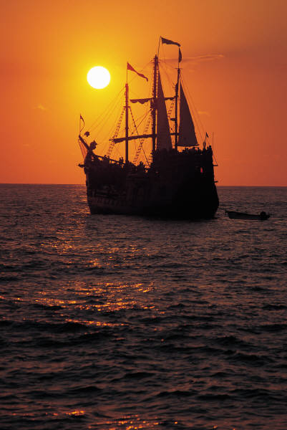

**SaYL Committee**

**c/o Cindy Phillipi**

**PO Box 278**

**Friendship, WI 53934**

**cphillippi@co.adams.wi.us**

**Signature Form:**

Applicant Signature: ________________________________

Parent/Guardian Signature: __________________________

(Y N) I grant Adams County the right to *u*se, publish, and copyright my child’s image, name, address, and phone number for education programs, website and promotion of County programs. The county adheres to all Federal & State Laws associated with this use.

**(Serving as YOUTH Leaders)**

**Application**

*SaYL*

**DUE: December 1st**

**LastName:__________________________________First:________________________________M.I.______**

**Full Address:______________________________________________________________________________**

**DOB _____/___/___ Gender: M F**

**Phone: (____)______-___________ E-Mail:____________________________________________________ School:___________________________________________________ Grade:______**

1. **Please write about why you are interested in becoming a youth representative on the Adams County Board, not to exceed one page. Include the following questions:**

* **Leadership skills and experiences you possess that will help you serve your community as a representative on the County Board.**
* **How would you as a student benefit from serving as a representative on the County Board?**
* **How would Adams County benefit from your representation/participation?**

1. **Rank your interest in the following Adams County Board Committees.**
2. **5, 1 being greatest, 5 being least)**

**_____ Highway _____ Solid Waste**

**_____ Planning & Zoning _____ Land & Water and Resource & Recreation**

1. **List school and community activities you participate in:**
2. **If selected, will you be able to serve from December/January through May and commit your time & energy? (Y N)**
3. **Include one reference form from a teacher.**

**Send to:**

A joint venture between the: A-F School District, Adams County Government, and UW-Extension