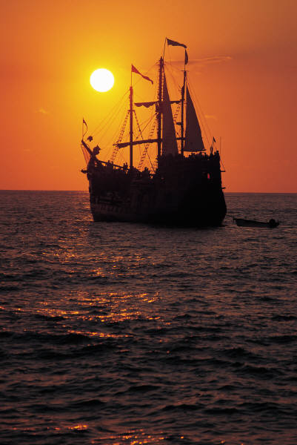

**(Serving as YOUTH Leaders)**

**Application**

*SaYL*

**SaYL Committee**

**c/o Cindy Phillipi**

**PO Box 278**

**Friendship, WI 53934**

**DUE: November 30, 2016**

**LastName:__________________________________First:________________________________M.I.______**

**Full Address:______________________________________________________________________________**

**DOB _____/___/___ Gender: M F Ethnicity: Hispanic/Non Hispanic Race: _______________**

**Phone: (____)______-___________ E-Mail:____________________________________________________ School:___________________________________________________ Grade:______ GPA (4.0 Scale) _____**

1. **Please write an essay on why you are interested in becoming a youth representative on the Adams County Board. In your essay be sure to address the following questions:**

* **Leadership skills you possess that will help you serve your community as a representative on a Committee.**
* **How would you as a student benefit from serving as a representative on the County Board?**
* **How would Adams County benefit from your representation/participation?**
* **Describe any experience you have working with individuals in a decision-making capacity.**
* **What kind of impact can you make in shaping the future of Adams County?**

1. **Rank your interest in the following Adams County Board Committees.**
2. **5, 1 being greatest, 5 being least)**

**_____ Extension ______ Parks ______ Highway ______ Solid Waste**

**_____ Planning & Zoning _____ Land & Water**

1. **List school and community activities you participate in.**
2. **If selected, will you be able to serve for (1) one year and commit your time & energy? (Y N)**
3. **List (3) three NON family references & include 3 written reference forms from them:**
4. **_______________________________________________________________**
5. **_______________________________________________________________**
6. **_______________________________________________________________**

**Send to:**

A joint venture between the: A-F School District, Adams County Government, and UW-Extension

**Signature Form:**

Applicant Signature: ________________________________

Parent/Guardian Signature: __________________________

(Y N) I grant Adams County the right to *u*se, publish, and copyright my child’s image, name, address, and phone number for education programs, website and promotion of County programs. The county adheres to all Federal & State Laws associated with this use.